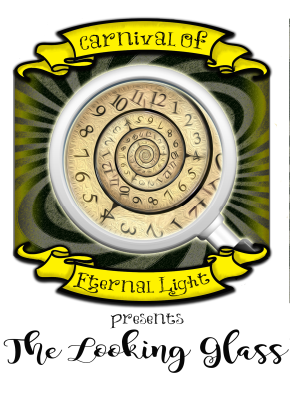

THE LOOKING GLASS HIRE INFORMATION

The Looking Glass is a multi – arts theatre production based on the Lewis Carroll Novels Alice’s Adventures in Wonderland & Through the Looking Glass. The Looking Glass will show us the magical and surreal world of the novels in a way never explored on stage before. With the use of many mediums of performance including Circus and Dance as well as the basis of the show being traditional Theatre, the audience will explore the world of Wonderland in a way that is immersive, enchanting and thoroughly breathtaking. The audience will experience the classic scenes, characters and concepts from Carroll’s work as well as entirely new and original scenes, characters and concepts created by the production team that will intermingle to create a vivid journey through Wonderland in a way which is familiar and yet startlingly new.

Below is a full breakdown of the hire information for The Looking Glass including all discount information. These fees can be reasonably negotiated.

Production Fee: £500*
*For two performances of the production in one day we shall deduct 10%

Travel Supplement*
*Based on travelling from Manchester

0 – 25: £30
26 – 50: £40
51 – 75: £60
76 – 100: £90
101 – 150: £120
151 – 200: £150

All plus any toll, parking and/or congestion charges

Full Hire Total
Based on travel distance*

Miles

0 – 25: £336
26 – 50: £376
51 – 75: £456
76 – 100: £526
101 – 150: £576
151 – 200: £646

*All Total Prices inclusive of VAT

